**Speculative Scale EXPLORER**

INTRODUCTION

This project is inspired by my own dissertation research, which partially focused upon a number of mid- to late-twentieth century media projects that divided the universe into discrete scales and presented them as a continuous, linear “zoom.” This project would build an online, collaborative platform for the exploration of scale as a series of scale-tagged image sets, or “speculative ecosystems.” The idea is to create a platform that allows users to speculatively conjoin scales by producing a series of images (each at its own scale) that are interconnected in some way, and then to allow other users to navigate within and between these sets, opening up multiple axes of scalar exploration and analysis. Such image sets could be photorealistic (photographs, micrographs, etc.) abstract (diagrams), or impressionistic (paintings, drawings, etc.). Similarly, the subject matter could be scientific (Hubble Space Telescope images, weather maps, scanning electron micrographs, etc.), loco-exploratory (produced to document a particular site or region), purely imaginative (representations of invented worlds) or interpretative-exploratory (representations of the scales of a novel).

Part of this project will involve designing and implementing the online platform itself, which would enable users to juxtapose and explore these speculative ecosystems along several axes: up and down the scalar axis of any given set, across networked connections between images rather than hierarchical scales, and through individual scales *across* multiple image sets.

The majority of the project, however, will involve the recruitment of students (and perhaps guest artists, academics, etc.) into workshops that would explore the concepts and configurations enabled by the platform (which can remain purely conceptual for much of this work) and produce particular image sets as the outcome of scholarly discussions. Concerns explored by these groups could include anything within the realm of scholarship amenable to analysis in terms of scale. Individual works of literature could be explored according to their scalar dynamics. Examples of literary scales could include:

* The scales of power within a work
* Social scales within a work
* Geographical scales within a work or body of works
* Scales of ecosystemic dynamics within a work
* Scales of fictional entities within a work
* The scales of literary reception / reading networks

Students will be encouraged to develop these projects as test cases for Speculative Scale Explorer exploration and analysis.

**Four Stages or Layers of Project**

1. POT images juxtaposed
2. Curated and user-submitted versions of speculative ecosystems.
3. Randomly generated speculative ecosystems (from image databases).
4. Automatically scaped images from online sources (NASA, observatories, medical institutions, Flickr? Instagram? Facebook?)

**BACKEND**

* All images organized into “ecosystems” (sets)
* Each ecosystem contains a set of empty scales. Every image in an ecosystem must be tagged with a a scale, there can't be more than one image with the same scale tag.
* All images with scale tags, are stored in a central repository, drawn from in both randomly generated ecosystems and comparison modes.
* Other tags: source, media (photo, CGI, drawing, painting), representation (imaginary, scientific, casual), connections (to other scales), intra-scalar dynamics (yes, no; optional list).

**USER INTERFACE**

Divided into two modes: Ecosystem and Scale Comparison. Ecosystem modes displays a set of images (a speculative ecosystem), and allows the user to move laterally to other speculative ecosystems. Scale Comparison mode displays a lateral group of (randomly selected) images, all at the same scale.

The user can switch between the two modes at any time by clicking an icon at the upper-right corner, which remains in the same position always (displaying the current mode).

When switching from Scale Comparison mode to Ecosystem mode, the interface displays the ecosystem of which the currently viewed image is a part. When switching into Scale Comparison mode, the currently selected scale (if user is currently in Browser mode) is displayed in Browser view. If the user is in Frame or Network view, then the interface switches to Scale Comparison mode, Frame view, and one of the images from the current ecosystem is randomly selected to populate the frames, along with a host of other images of the same scale from different ecosystems (randomly selected from the full database).

**ECOSYSTEM MODE**

This mode has three views: Browser, Frame, and Network.

*Browser* view examines a single scalar image at a time, along with links to any other connected scales within the same ecosystem. These appear as thumbnails below the currently selected scale, and can be navigated to with a single click. Contextually appearing arrows to the right and left of the main image will change the current main image to another from the current ecosystem: RIGHT ARROW = one scale larger (consecutively), LEFT ARROW = one scale smaller.

*Frame* view displays a number of images from the current ecosystem. The central area of the page is devoted to a dynamically changeable number of frames, each of which contains a reduced-size image at the same (current) scale. Selectable frame options:

4 (2 x 2 grid)

8 (2 rows of 4)

15 (3 rows of 5)

24 (4 rows of 6)

If switching from Browser view (in either Ecosystem or Scale Comparison mode), then the currently displayed image will be loaded into into one of the frames, approximately central on the screen.

*Network* view displays every image (in thumbnail form) from the current ecosystem, in a network drawn from the “connections” field in the metadata. Clicking on any individual node (thumbnail) switches to Browser view and loads that image. This allows for an intuitive exploration of a speculative ecosystem as a series of scalar interconnections rather than as a linear (or concentric) range of scales.

**SCALE COMPARISON MODE**

Two different “views” are possible in this mode: Frame and Browser.

*Browser* view displays one single image at a time, in the center of the page, as in Ecosystem mode. However, this image is positioned at the center of two axes, vertical and horizontal. Small thumbnails of other images at the same scale appear to the left and right of the main image. The user can advance to them by clicking on them directly, or on contextually appearing arrows to the right or left of the main image. In addition, thumbnails also appear above and below the main image. These are images within the same ecosystem as the current image, but at different scales.

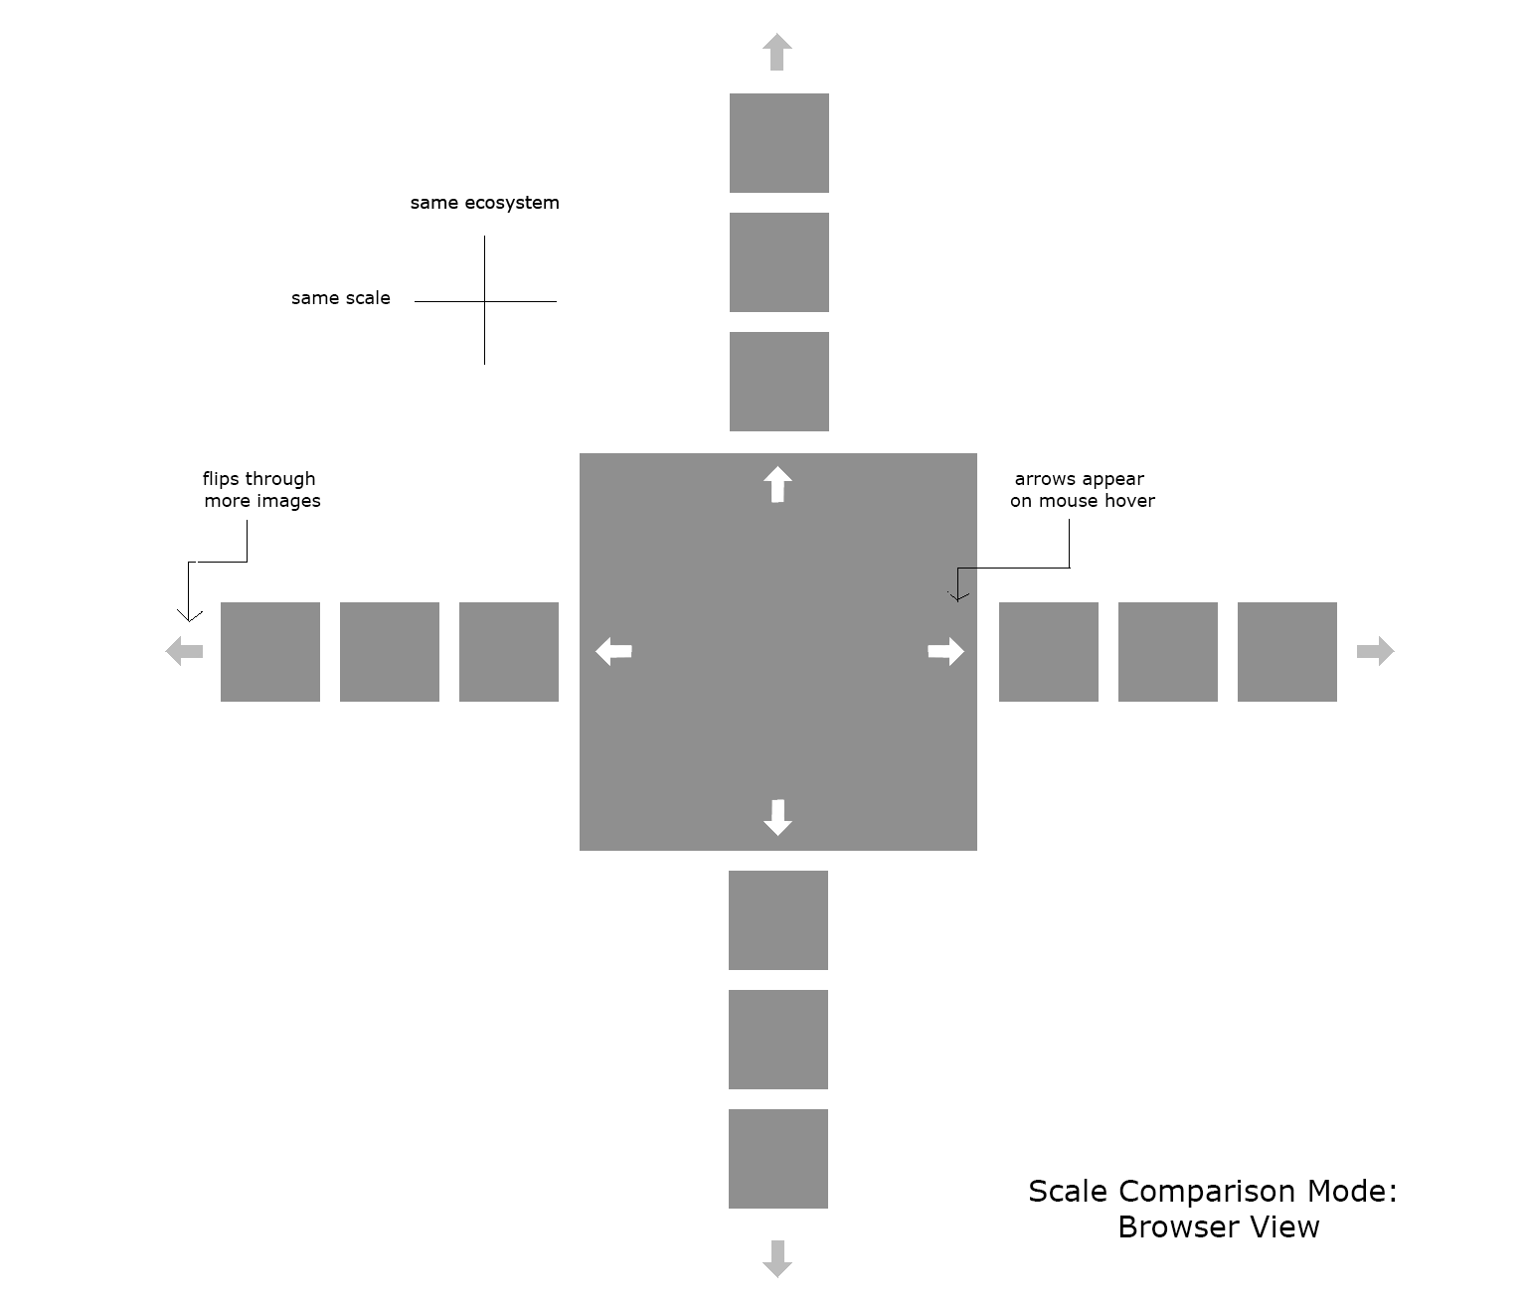

*Frame* view: In this view, which is interfacially identical to Frame view in Ecosystem mode, the central area of the page is devoted to a dynamically changeable number of frames, each of which contains a reduced-size image at the same (current) scale, but from completely different image sets (ecosystems). This view thus displays a collage of images at the same scale, randomly drawn from the image sets in the system’s database. Selectable frame options:

4 (2 x 2 grid)

8 (2 rows of 4)

15 (3 rows of 5)

24 (4 rows of 6)

In this view, clicking on any image switches to Browser view and opens that image.

Sites for inspiration

[theyrule.net](http://www.theyrule.net/) - create maps and connections between powerful companies/people

[visualizing.org/explore#](http://visualizing.org/explore#) - data visualizations

Layout ideas

[d3js.org](http://d3js.org/) (Javascript library) - for creating data visualizations

[jssor.com](http://www.jssor.com/) (Javascript) - vertical and horizontal image slider, could be edited more to suit needs